What Influences the U.S Fed Rates The Most?

Raian Khan
The City College Of New York
Spring Econometrics
May 2026

Abstract

The US federal reserves have long been independent from other chambers of government, serving the American people based on the current state of the economy. There are many economic factors that affect federal reserve interest rates, such as macroeconomic events, inflation, how strong the labor market is etc. Recently interest rates have been cut a lot to alleviate some pressure on the economy. We want to understand what some of the main drivers are and if there are other drivers that we do not know about that could also affect rates. This is important as knowing how the economy is doing based on a multitude of factors. The time frame used for this research will include the last 20 years starting from January 2026, all the way dating back to January 2006. During these last 20 years we had 2 different recessions, the Great Recession of 2008 and COVID Pandemic of 2020, so examining federal rates during this time frame is ideal to examine if any real correlation exists between fed rates and the multitude of factors. The programming language R within RStudio to create, model and run all my regressions. All graphs and summary statistics will be created to examine further the relationship of Federal Rates and the multitude of factors that can have an influence in either raising or cutting rates. There will be a total of 13 regressions that will be ran for this research. The first 7 are pre-transformation regressions and the rest of the 6 regressions are either transformed regressions or regressions used to diagnose an issue.

Introduction
This paper will examine what really decides the Federal Reserve to adjust its rates. We need to understand what really causes rates to change. Whether it is through unemployment or how strong the job market is or there's other underlying factors that really signify the need for rate changes. Understanding where the real issues are that affects federal rates and that in turn also affects the economy can help us really lay the focus on specific issues that would need to be addressed. There will be 2 hypotheses that I want to explore, my first one being that high unemployment allows Federal Funds Rates to decrease and my second one is that inflation near the target rates of 2 percent causes rates to increase when signaling that the economy is in a healthy direction. Usually these 2 factors are the main root cause of federal rate changes.
This paper will attempt to answer the basic question of what are some causes of rate changes behind the 2 main factors which are unemployment and level of inflation. I have explored 2 papers and a blog post in regards to similar situations from universities.

Moving forward with this research will provide many models tested, diagnosed, and transformed in order to understand the root of Fed Rates changes. There are 10 variables being used and 3 of them marked as main regressors, while 2 of them are dummies created, and the rest of the 5 variables are regressors that may pose an effect. Graphs and summary statistics are heavily used to understand the cause.

Literature Review
A research that was completed by Southern Methodist University iterates some of the bigger macroeconomic factors that really controls the Federal Funds Rate. The Federal Reserve eyes the potential of inflation of around 2 percent, and adjusts its rates based on how probable that goal is. Also mentioning that unemployment determines the health of the labor market. A research article through researchgate stated that Federal funds rates and unemployment were some of the biggest factors considering rate changes, historically rates have been high to combat high inflation as mentioned in this article “In the 1980, inflation shot up to the highest amount in history: 14.6 percent. To control inflation, the Fed set a target of 14% over the next decade for the funds rate.” A blog from University Of Wisconsin mentioned that there needs to be a balance between setting rates to ensure the economy does not flip upside down and a lot of events outside of unemployment and inflation to some level is outside of the Fed’s control. These articles summarize the fact that the reserve adjusts its rates based mainly on unemployment and inflation to assist in stimulating the economy but has limited power to assist in controlling outside events such as supply chain issues or anything else global related. My project compares to a lot of these other papers and blogs as I am using the 2 main variables of fed rate changes such as unemployment and inflation, with the main difference being that I am adding other variables such as Tariffs, GDP, and Job Revisions. As of right now unemployment with the relation to fed rates has come out to be a strong relationship so far and matching with one of my hypotheses of whether high unemployment causes rates to be lowered.

Data
The dependent variable for this research will be the Federal Reserve Rates in percentage points coming from FRED. This is the variable that will be looked at to answer the question what causes rates to fluctuate. This rate affects various loaning, mortgagesThe independent variables are inflation via CPIAUCSL available from FRED, unemployment in percentage points available from Bureau Of Labor Statistics, Job Revisions also available from Bureau Of Labor Statistics, Personal Expenditure in percent change, QQQ index fund data coming from Yahoo Finance.

Monthly data for all variables will be used starting January 1st 2006 and will be merged into one final dataset to examine and run regressions on. Fed Rate levels will be changed into monthly data since they update every 3 months when the Federal Reserve holds its meeting and concludes. I will be converting it to monthly data therefore it is easier to understand whether rates have changed from one meeting to the next. Inflation(CPIAUCSL), job revision, and unemployment by default come with monthly data so the main thing would be just to merge along with the fed rate data. The QQQ Index comes with daily data, so essentially that will have to be converted into monthly data taking the total return for that specific month. Personal Consumer Expenditure comes with data that is updated every quarter, around three or four months, so a change to monthly will be necessary.

Two dummies have been created for this research, the first being the tariff dummy to represent the tariff policy changes during 2018 to 2020 between the United States and China because tariffs also have an effect on inflation when enacted. A time variable was also created to represent long term changes that otherwise other variables cannot explain.

The variable PCE ( Personal Consumption Index) which represents people's spending habits and how they change. This accounts for all businesses and households that reside in urban and rural areas. An interesting finding from the University of Wisconsin in which they mentioned the Feds using this as a way of determining rates rather than CPI (Inflation). This also will be an alternative way to examine percentage changes in inflation and the level of inflation itself from month to month as well as unemployment changes.
Methodology
My research aims to uncover what really are the main causes of federal rate changes because it has always been talked about with advocates of cuts, not changing it, and even raising it. This is important to understand as these rates influence the U.S economy with not just businesses and whatever their rates may be but also interest rates on the people as well, when it comes to buying homes or property and even taking out loans for such reasons.

My Current Regression Base Equation:
- FedRate= a + B1(Unemployment) + εt
My next 6 models will feature more variables and goes as follows:
- FedRate= a + B1(Unemployment) + B2(Inflation_Monthly) + B3( Inflation_Monthly Change) +εt
- FedRate= a + B1(Unemployment) + B2(Inflation_Monthly) + B3( Inflation_Monthly Change) + B4( Tariff_dummy) +εt
- FedRate= a + B1(Unemployment) + B2(Inflation_Monthly) + B3( Inflation_Monthly Change) + B4( Tariff_dummy) + B5(Personal Consumer Expenditure)+εt
- FedRate= a + B1(Unemployment) + B2(Inflation_Monthly) + B3( Inflation_Monthly Change) + B4( Tariff_dummy) + B5(Personal Consumer Expenditure)+B6(Job Revisions+εt
- FedRate= a + B1(Unemployment) + B2(Inflation_Monthly) + B3( Inflation_Monthly Change) + B4( Tariff_dummy) + B5(Personal Consumer Expenditure)+B6(Job Revisions+B7(Time)+εt
- FedRate= a + B1(Unemployment) + B2(Inflation_Monthly) + B3( Inflation_Monthly Change) + B4( Tariff_dummy) + B5(Personal Consumer Expenditure)+B6(Job Revisions)+B7(Time)+B8(QQQ Returns)+B9(GDP) + εt ( Final Regression Equation )

I will be utilizing the classic OLS regression to run multiple models to support my research. The alpha within these proposed regressions will be the constant or the average of all my variables when they are set to 0, meaning no independent variables will affect the alpha. The final proposed regression equation model includes a consideration of the labor market, the stock market, a policy such as tariffs, and population spending inflation. Some of my controls will be inflation, GDP, and unemployment.

Inflation has an impact on people’s purchasing power by the day and is important for us to understand whether this has any impact on the cause of the change of fed rates. Unemployment is important to determine how healthy the job market is right now and is one of the biggest factors of the economy in almost every aspect. I also have job revisions as a variable related to the health of the job market, that determines how many jobs are added and/or lost each month. Personal Consumer Expenditure is also a different branch of inflation, in the sense of the total value of goods that are purchased by the people or businesses in urban and rural areas. This can also be observed as inflation on a personal level and according to the University Of Wisconsin, is the main driver of setting interest rates from the Federal Reserve. These variables are always a constant issue within not just the Federal Reserve but also within the government themselves when considering different policies. They all have an impact on the economy and the people buy the day when it comes to interest rates.

There were some auto multicollinearity issues since most of these variables are being converted through monthly. When GDP was introduced to the equation of my model, all of a sudden both my time variable that I created and GDP variable had a massive multicollinearity error with GDP having a VIF of 19.32 and GDP of 15.95. I have run 2 new regressions that I will show in the results section and explain why I ran them separately in the “Results” section and also have provided a bar graph (4a).

Running New Regressions, Time vs GDP
- FedRate= a + B1(Unemployment) + B2(Inflation_Monthly) + B3( Inflation_Monthly Change) + B4( Tariff_dummy) + B5(Personal Consumer Expenditure)+B6(Job Revisions)++B7(QQQ Returns)+B8(GDP) + εt
- FedRate= a + B1(Unemployment) + B2(Inflation_Monthly) + B3( Inflation_Monthly Change) + B4( Tariff_dummy) + B5(Personal Consumer Expenditure)+B6(Job Revisions)+B7(Time)+B8(QQQ Returns) + εt
I have also leveraged log transformations in my regressions as well with my main regressors that were presumed to have an impact on this research. Those variables being inflation, Personal Consumer Expenditures, unemployment. Since log regressions are used to represent change, I wanted to experiment the effects of implementing change to my variables since these variables are always changing over time, at different rates, but still important to observe how these regressions will react to logging these main regressors.

Logged Regressions Models:
- FedRate= a + B1(Log_Unemployment) + B2(Inflation_Monthly) + B3( Inflation_Monthly Change) + B4( Tariff_dummy) + B5(Log_Personal Consumer Expenditure)+B6(Job Revisions)+B7(Time)+B8(QQQ Returns) + εt
- FedRate= a + B1(Log_Unemployment) + B2(Inflation) + B3( Inflation_Monthly Change) + B4( Tariff_dummy) +B5(Job Revisions)+B6(Time)+B7(QQQ Returns) + εt
- FedRate= a + B1(Log_Unemployment) + B2( Tariff_dummy) + B3(Job Revisions)+B4(Time)+B5(QQQ Returns) + εt
- FedRate= a + B1(Inflation) +B2( Tariff_dummy) +B3(Job Revisions)+B4(Time)+B5(QQQ Returns) + εt

Results
My results for my standard regressions are as follows below:
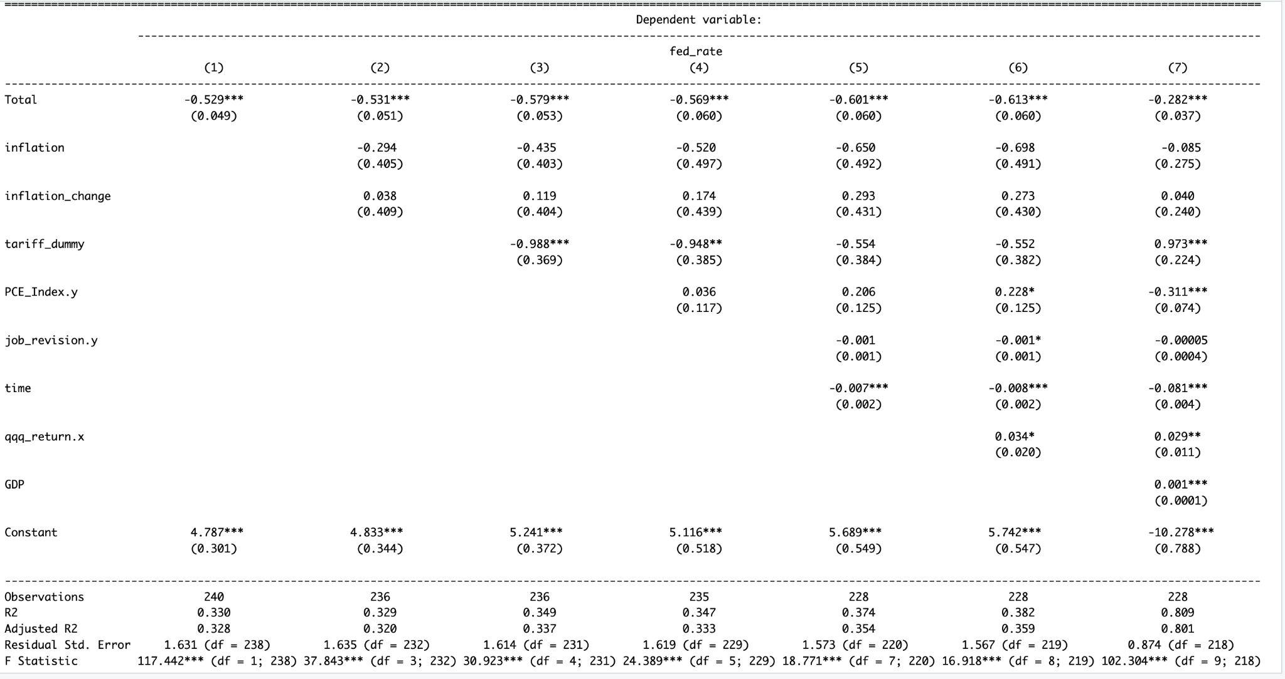
We can see that regressions one through 6 all run normally with reasonable adjusted r2 values ranging from 0.32 to 0.35 and picking out variables that have an important factor through running these regressions. However we can see that regression #7 had an very high r2 and adjusted r2 value of 0.809 and o.801 respectively. This can either indicate that there is a variable that has been found to be the main influence of the dependent variable which is the fed_rate.

Unemployment has remained one of the most significant factors when it comes to fed rate changes. When observing some of these statistics of unemployment, for example in regression 6 before GDP variable was introduced we see that there are three stars next to them similar to all of the other regressions tested before six. This means that when unemployment is up by 1 single percentage point, rates are approximately cut by -0.61 percentage points. The bottom number has a small number meaning this is a very precise estimate. This estimate explains that when unemployment is rising, the fed rates are being brought down to help stimulate the economy during a point where the job market may be showing signs of slowing down.

As mentioned earlier, the multicollinearity issues in regression seven between the variables and GDP, in terms of a technical standpoint, the model thought it was the same variable however in a context standpoint it was not. The main reason this was an issue was because time was created in a monthly format and is always increasing, while GDP is also increasing almost rarely having any dips. My solution to this was to run 2 separate new regressions that way finding out whether GDP or time is the less important variable. I have run 2 separate new regressions with the same structure as the final regression equation except leaving one and the other variable out.

When it came to running these new regressions separately. It was found that results turned out a lot better and no multicollinearity was detected. When considering all variables except for GDP and Time while running these two new regressions, it was found that GDP actually was not a significant variable and the variable “time” that was created was actually more important. (Appendix (2a,2b,2c)). This is because the time variable captures hidden long term trends that any other variable cannot. Without the time variable a lot of these variables would be suffering from spurious correlation in which models being run will think that they are correlated when they’re not.

My log regressions results are as follows below after examining multicollinearity with the previous regression:
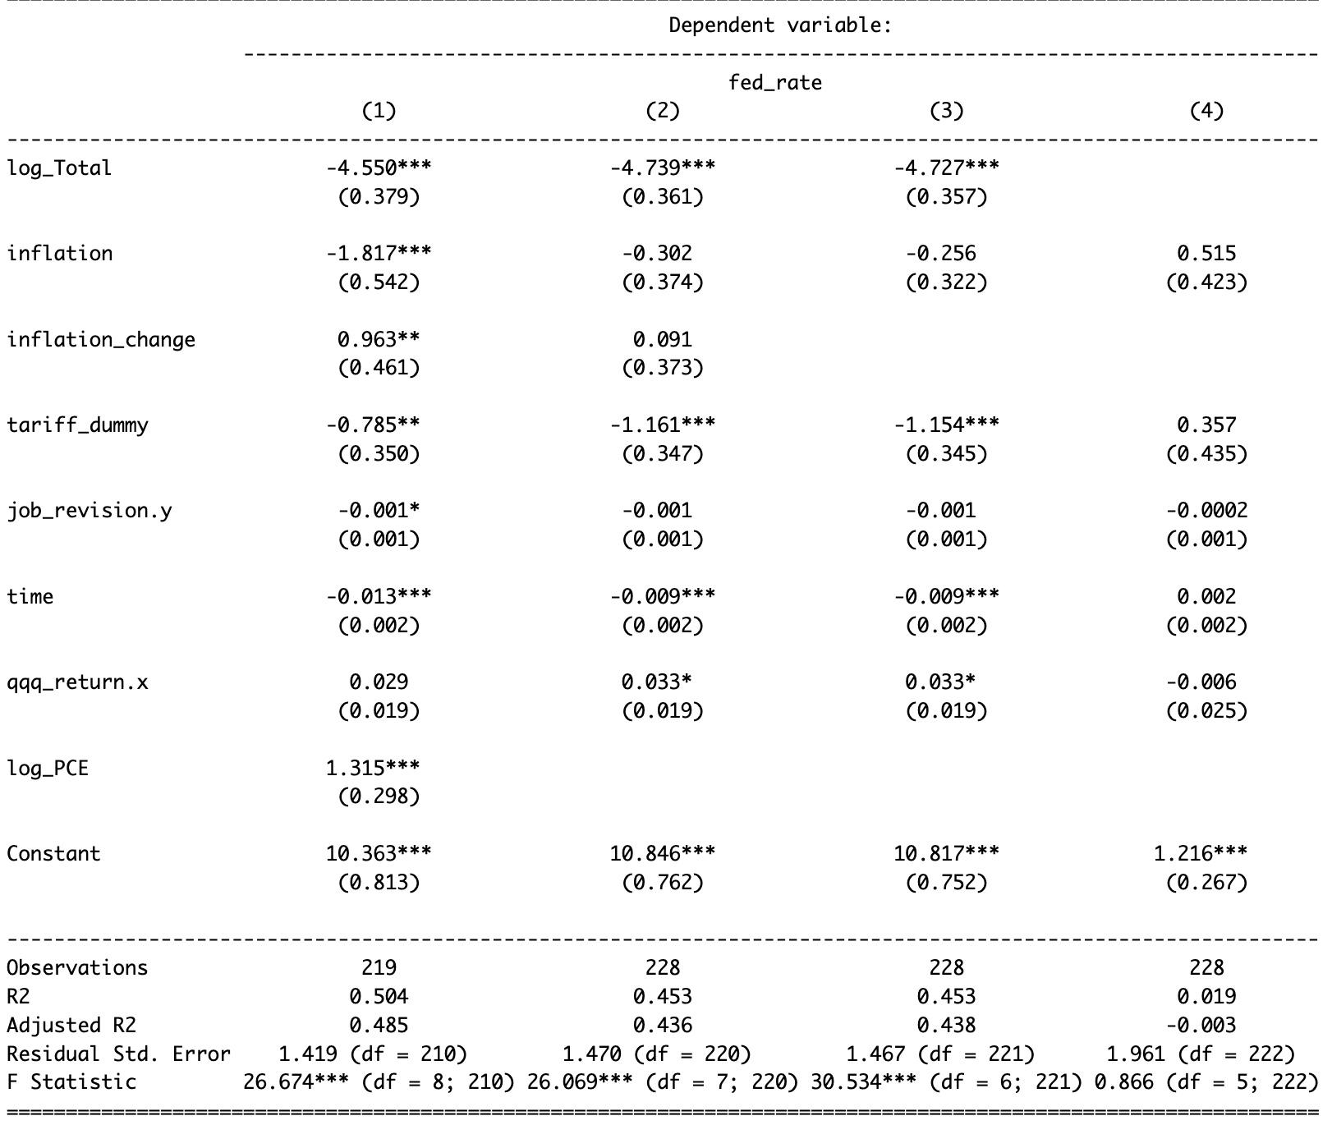
I transformed some of my main regressors which were Personal Consumer Expenditures, inflation and unemployment. Taking a look at all of these regressions performed, Unemployment has remained a consistent significant variable throughout all of the variables. This time when logging the main regressors, we see a much bigger top number and bottom number. In this context it would be saying that everytime unemployment was up one percentage point, the fed rate would be cut by 0.0455 points when transformed back from log results, same with its bottom number as well indicating it is also a precise estimate. However reducing the rate by only 0.0445 percentage points will not offset any rising labor market issues or domestic economic issues.

Unemployment stands as one of the most important factors when it comes to determining what causes fed rate changes. However, job revisions when running regressions stated it was not as significant however looking at the pattern of the graphs, it seems to have some pattern when it comes to bigger crises. According to the graph in (Appendix 7.) You're able to see that past the first structural break which was the start of the 2008 recession when job revisions spiked down, fed rates also dropped to near 0. Past the second structural break past 2015, which the actual date was May 2016, there were consistent positive job revisions and therefore rates were starting to rise before the COVID pandemic of 2020.

When the personal consumer index was originally run in the first seven regressions, according to the summary statistics, it was not a significant variable. Logging the variable and having it represent change actually made it more significant. Due to the variable only showing the level of the index every 3 months, the original regression was only accounting for the level it was at, rather than a percent change. This was one of those variables where a small increase may not signify anything major, but logging personal consumer index showed bigger changes when running it in a log regression that regular OLS regression could not otherwise. According to the logged summary statistics above looking at log_PCE having a number of 1.31. When this is adjusted for a one percent change, it evaluates at every percentage point the personal consumer index increases by the Fed Rate increases by 0.013 percentage points.

Structural breaks exist within all of my models, the first 2 breaks being the 2008 Great Recession and the 2020 COVID Pandemic via the chow test. Inputting the dates of when these 2 recessions started confirmed that these 2 breaks had values of higher than. However a new break was found near May of 2016 using the Bai-Perron breakpoint test essentially confirming the 2 breakpoints previously found using the chow test, however this new breakpoint was found. This makes sense as we refer to the graph Job Revisions and Unemployment vs Fed Rate (Appendix 3 and 7) we are able to see that while unemployment was decreasing consistently during the recovery of the great recession of 2008, the Federal Reserve started to raise rates signifying a successful recovery and improving economic conditions. The other breakpoints observed (Great Recession and COVID) using the graphs mentioned using the Bai-Perron test also remained consistent with the chow test.

Conclusion and Findings
Unemployment was the largest factor in fed rates across all tested models logged and standard OLS regressions. According to the graph, if unemployment is up or if the job market is looking a little rough on a consistent pattern or rates get lowered, but if the economy does well with consistency and unemployment drops the feds will raise rates signifying an improving economy. However major geopolitics can affect the economy in a big way to the point that feds can't do anything about it but just watch how it is affected. Dropping rates significantly at once can do more harm than good if the economy is still functioning even if geopolitics is in the way.
Some limitations will be that not all observations are being tested. Over a 20 year span and 250 revisions, only 219 are actually being observed when accounting for all variables and accounting for change over time for some variables. There are also some signs of endogeneity as inflation can make the Fed react and vice versa. Job Revisions when running regressions stated it was not as significant however looking at the pattern of the graphs, it seems to have some pattern when it comes to bigger crises but the statistics summary showed it was not that relevant.
The Federal Reserve should continue to monitor unemployment, job revisions, and inflation to really determine if changes are necessary to the rates. They should be looking for clear consistent patterns within a timeframe and if a trend exists they should act upon it otherwise leave rates as is.
Appendix

1.Fed Rate and Job Revision Graph:
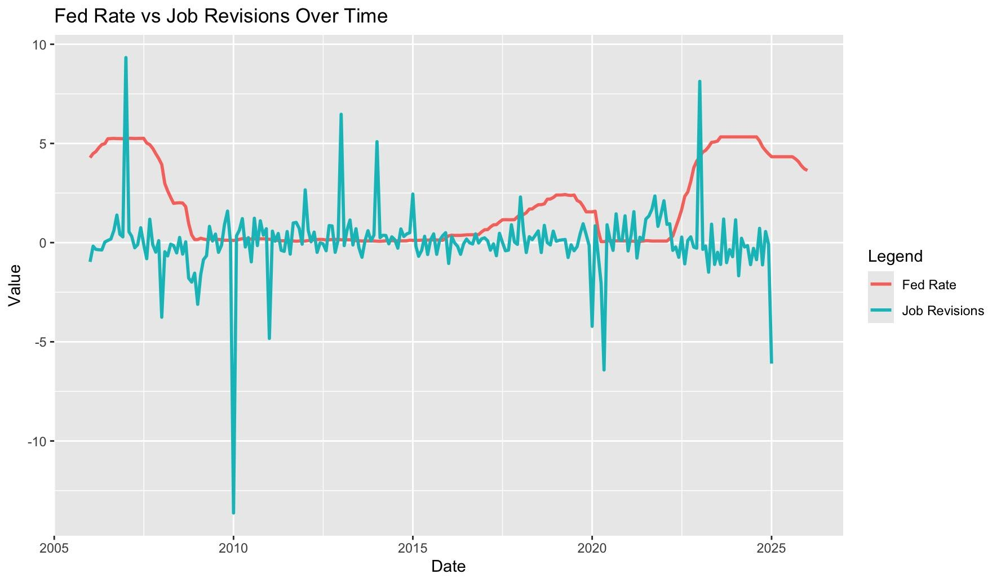

2a.Time And GDP Ran Separately:

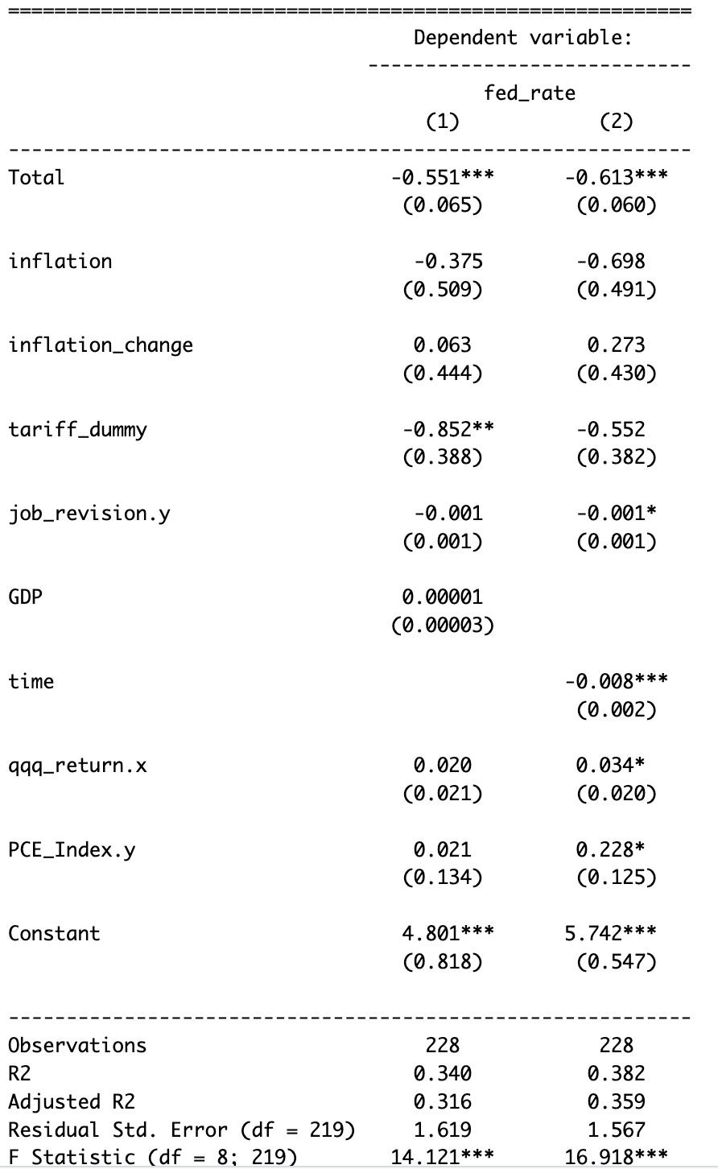

2b.VIF Statistics Check For Time :
2c. VIF Statistics Check For GDP
3.Structural BreakPoint Shown With Dashed Lines
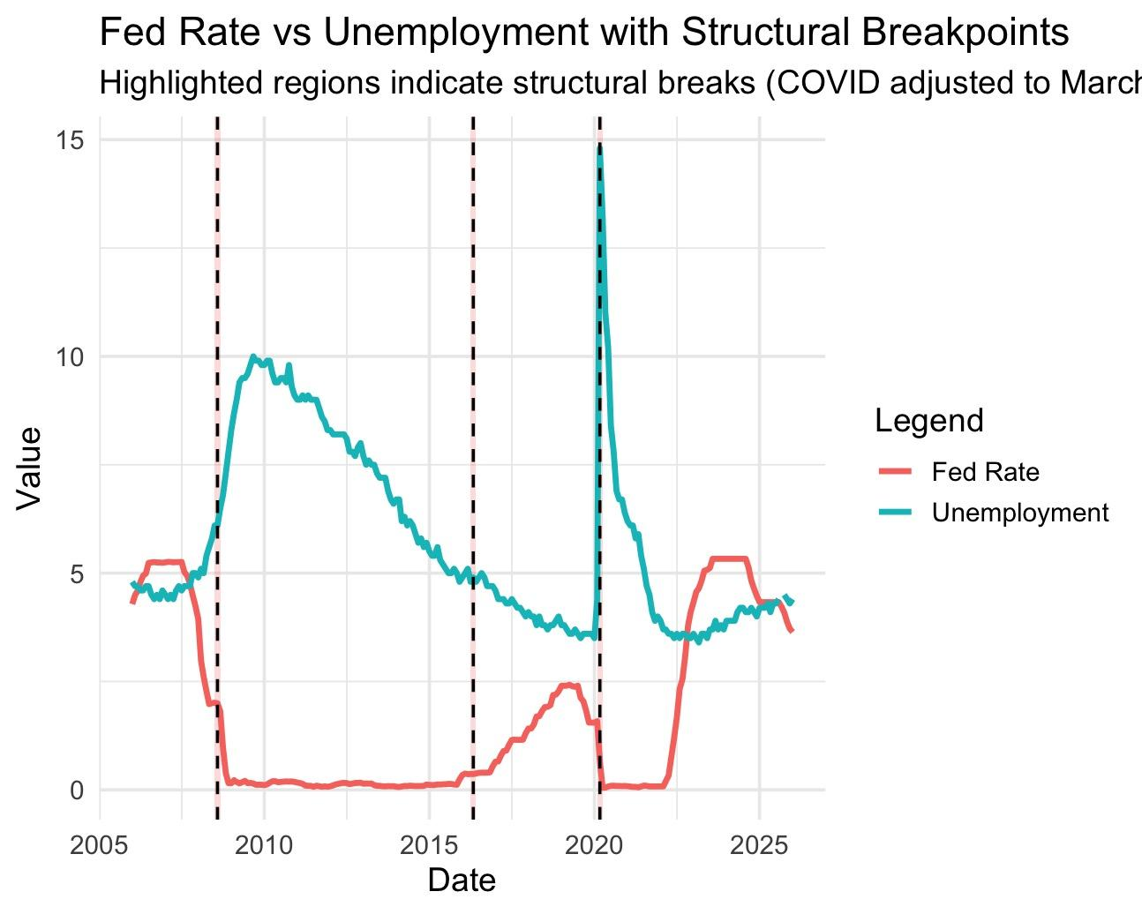
4a.Multicollinearity Check For Original Regression #7
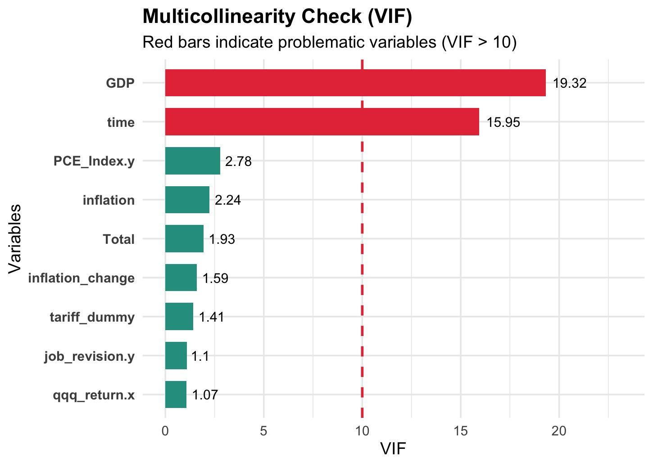
4b.Regression #7 multicollinearity statistics when GDP was logged
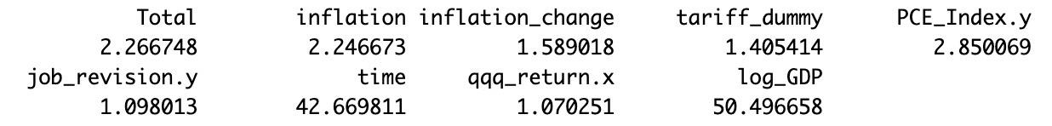
5.FedRate and Log Personal Consumer Expenditure Graph
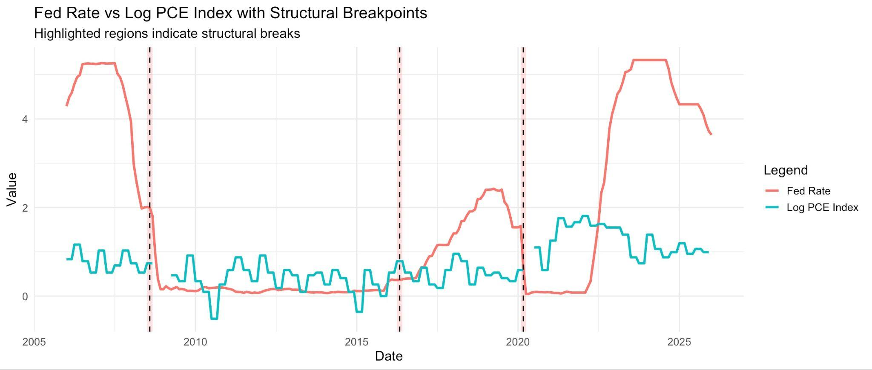
6.FedRate and Inflation Graph
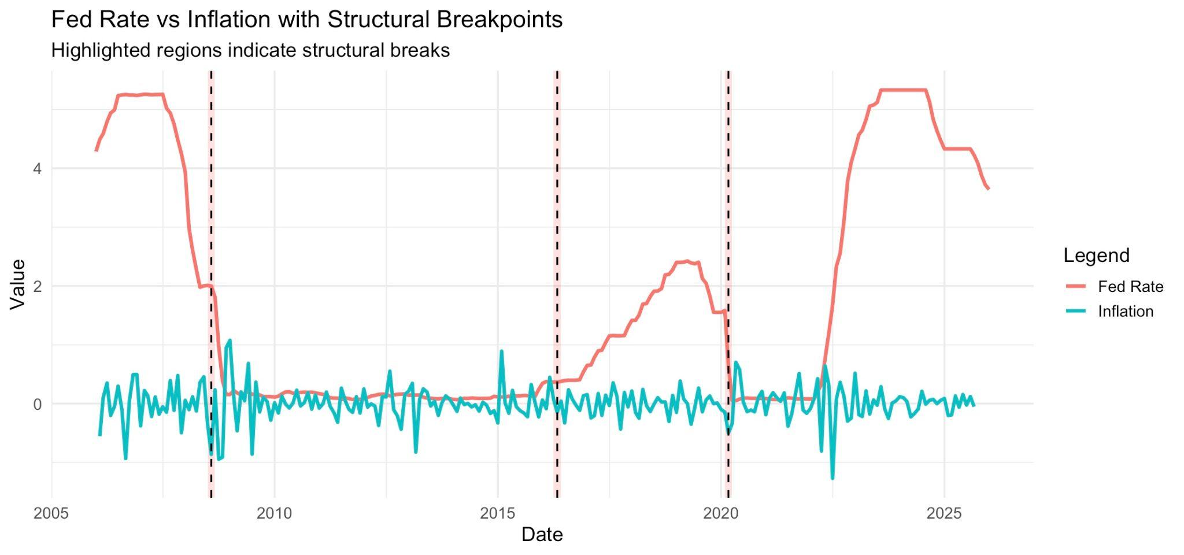
7.FedRate and Job Revisions Graph
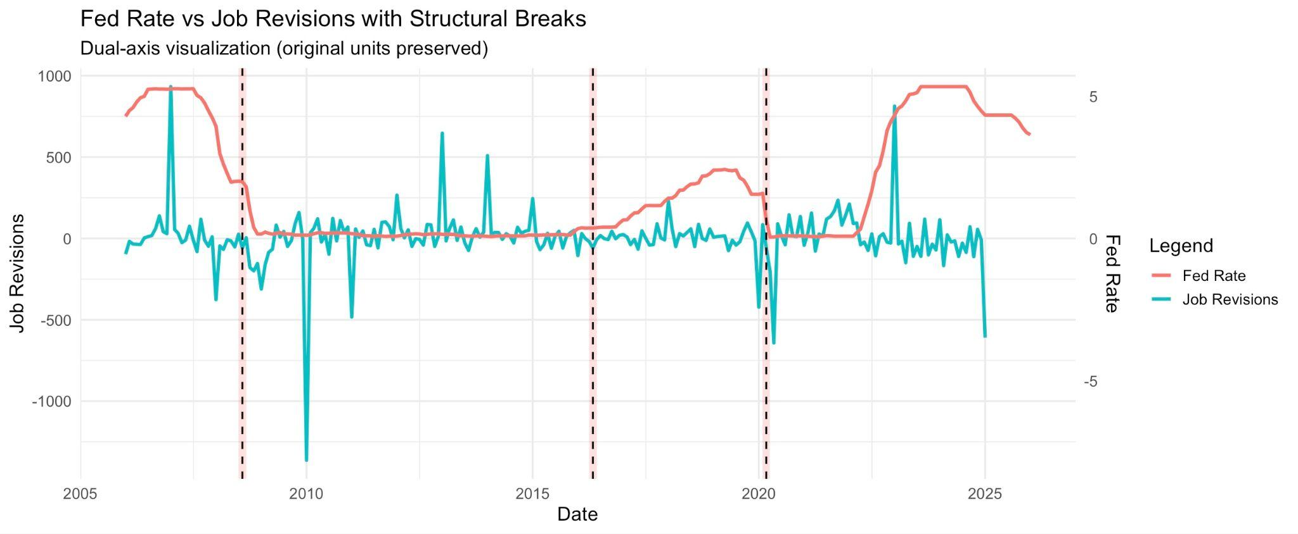
8a.Outliers Graph For Logged Transformation
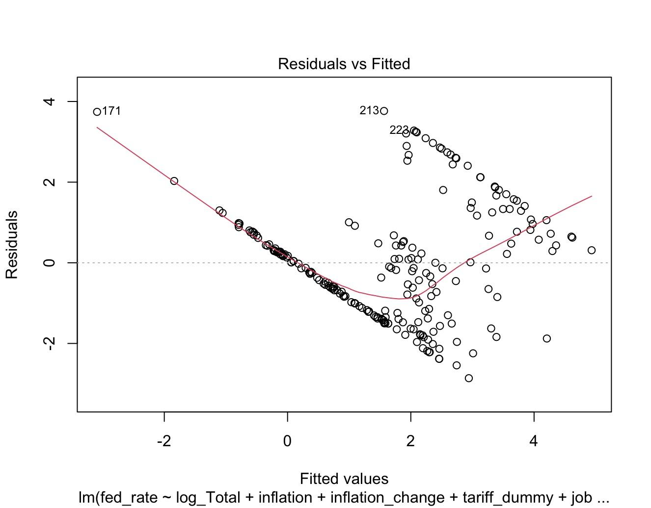
8b.Outliers List
9. VIF Check for Logged Regressions
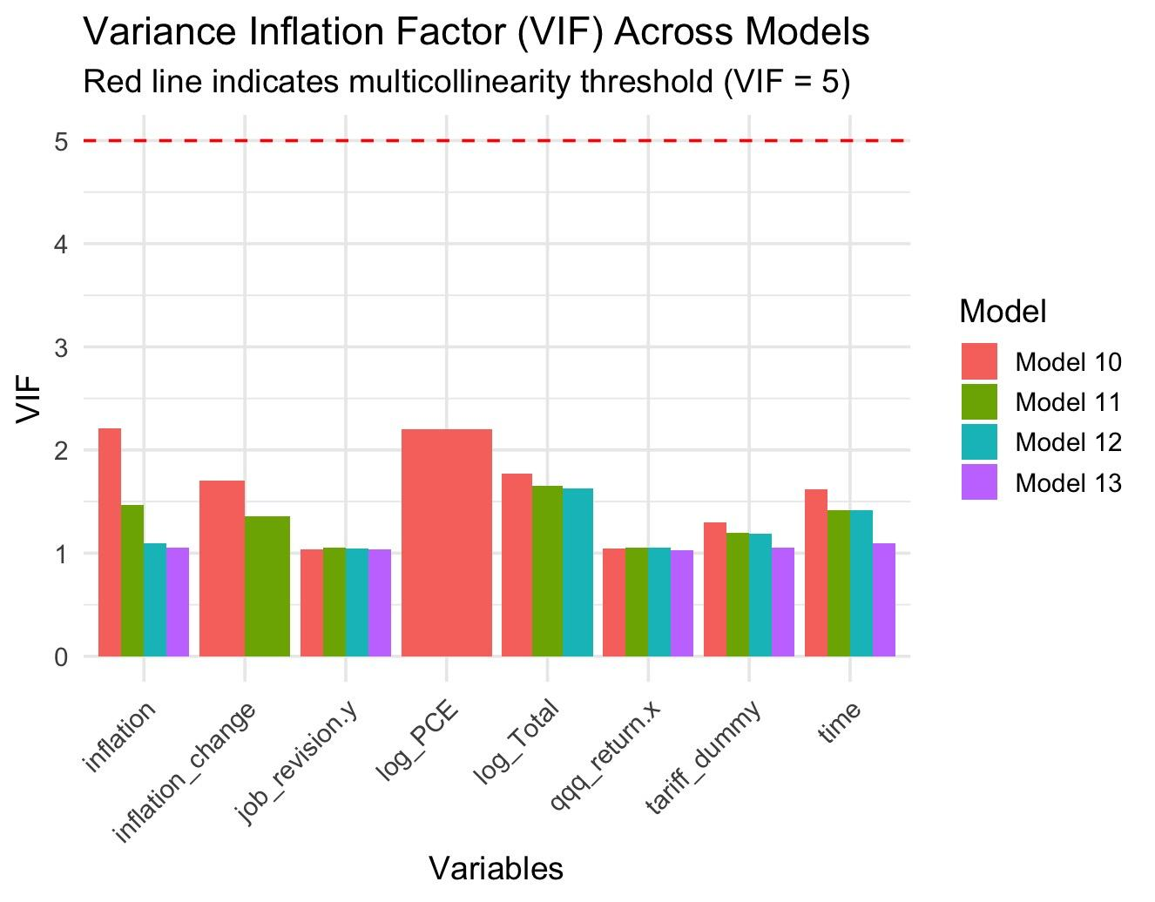

Citations:
University of Wisconsin–Stevens Point Blog. “The Federal Reserve and Interest Rate Changes.” University of Wisconsin–Stevens Point Blog, March 25, 2025.
SMU Data Science Review Paper. SMU Data Science Review. “Data-Driven Analysis of Federal Reserve Policy and Macroeconomic Indicators.” Southern Methodist University, accessed May 18, 2026.
ResearchGate Paper on Fed Rate Hikes and USD Exchange Rate. “Impact of the Federal Reserve Interest Rate Hikes on the US Dollar Exchange Rate.” ResearchGate, 2024.

BLS Unemployment Rate Data. U.S. Bureau of Labor Statistics. “Civilian Unemployment Rate.” Accessed May 18, 2026.
FRED CPIAUCSL Series. Federal Reserve Bank of St. Louis. “Consumer Price Index for All Urban Consumers: All Items in U.S. City Average (CPIAUCSL).” FRED Economic Data. Accessed May 18, 2026.
FRED Federal Funds Rate Series. Federal Reserve Bank of St. Louis. “Federal Funds Effective Rate (FEDFUNDS).” FRED Economic Data. Accessed May 18, 2026.
Yahoo Finance QQQ Data. Yahoo Finance. “Invesco QQQ Trust (QQQ).” Accessed May 18, 2026.
BLS CES Revision Information. U.S. Bureau of Labor Statistics. “CES Employment Benchmark and Revision Information.” Accessed May 18, 2026.

